## **Create a Real Developer Edition Org**

To get full access — including **Connected App creation**, **OAuth**, **API integrations**, etc. — you need to sign up for a **true Developer Edition org**, which has **no limitations** on these features.

### **Sign up here:**

<https://developer.salesforce.com/signup>

When filling it out:

* Use a **new unique email and username**
* You’ll get a login like: [yourname@yourdomain.dev](mailto:yourname@yourdomain.dev)

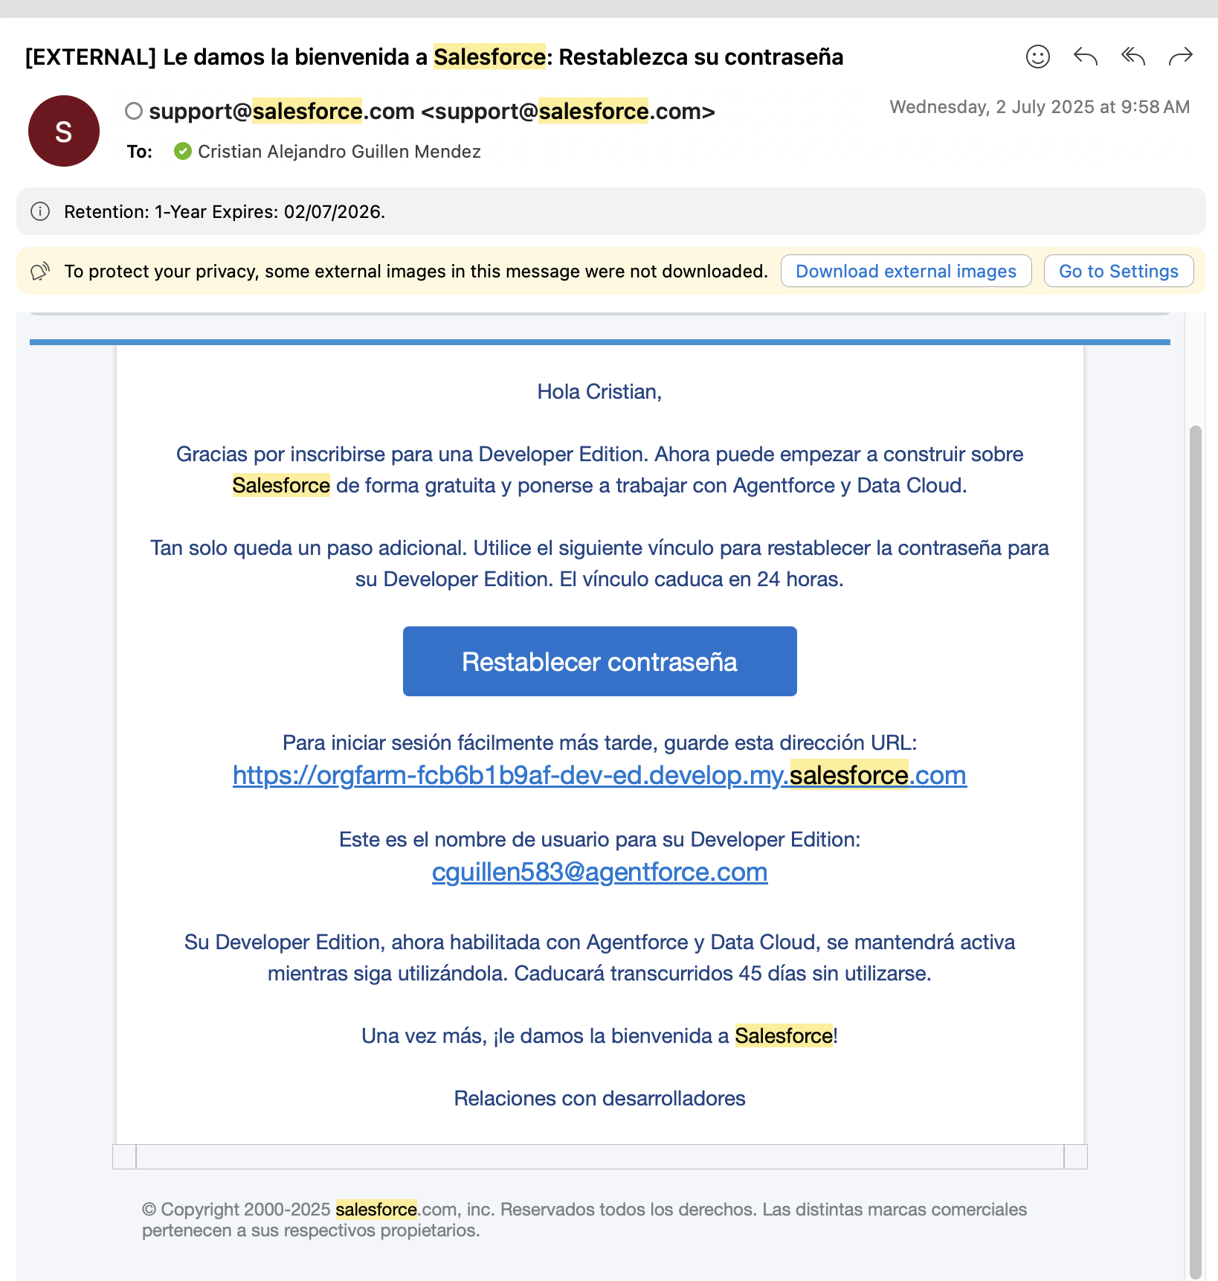

## **Generate Keys**

### Enable Connected Apps

1. **Go to Apps**→ External Client App→ Settings
2. Enable Connected App

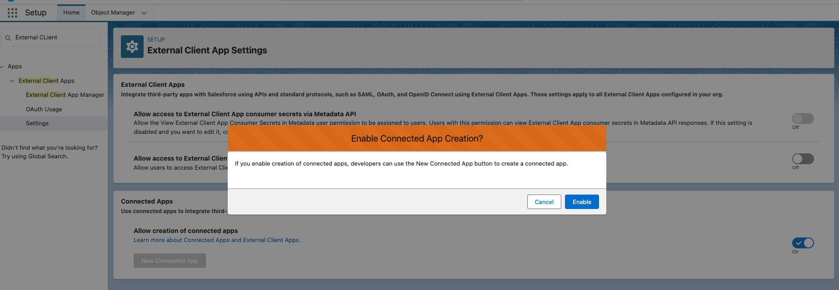

1. Click new connected App

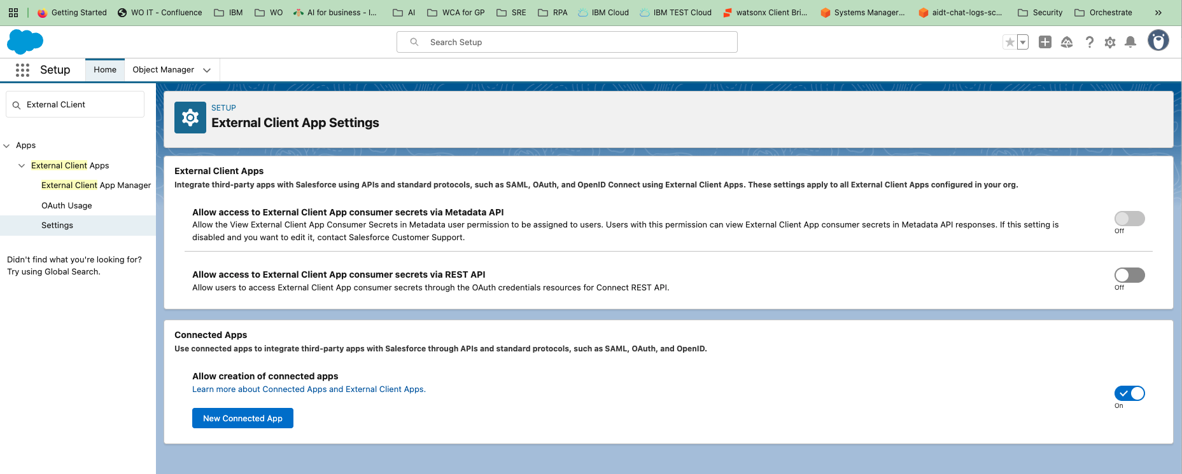

1. Fill required fields
   1. Connected App Name
   2. Api Name
   3. Contact Email

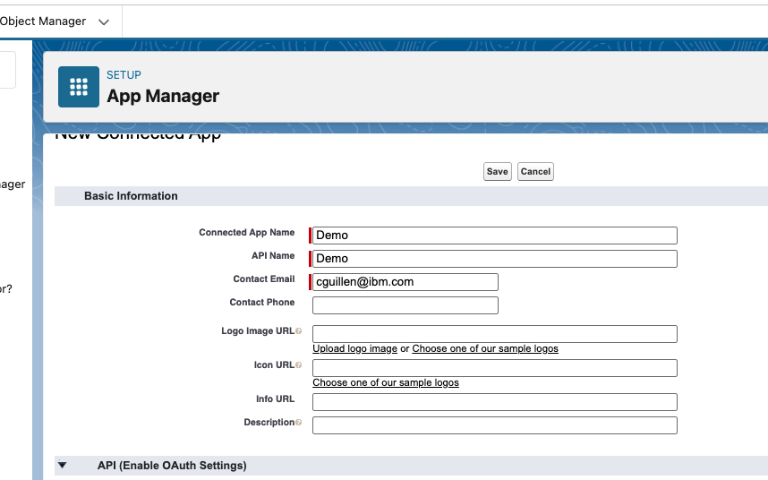

1. Enable "Enable OAuth Settings"
   1. Use “https://login.salesforce.com” in the callback url
   2. Available OAuth Scopes
      1. Chatbot_api
      2. Sfap_api
      3. Api
      4. Refresh_token
   3. Disable
      1. Require Proof Key for Code Exchange (PKCE) Extension for Supported Authorization Flows
      2. Require Secret for Web Server Flow
      3. Require Secret for Web Server Flow
      4. Require Secret for Refresh Token Flow
   4. Enable
      1. Enable Client Credentials Flow
   5. Issue JSON Web Token (JWT)-based access tokens for named users

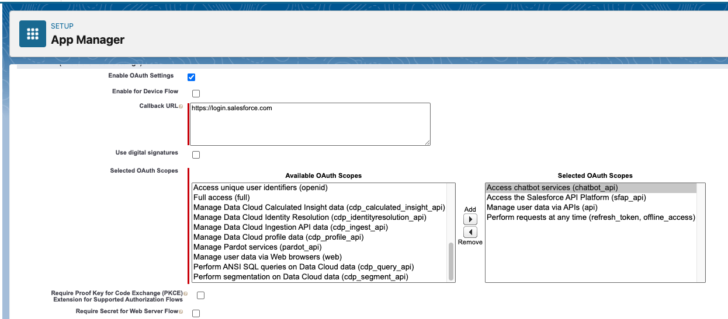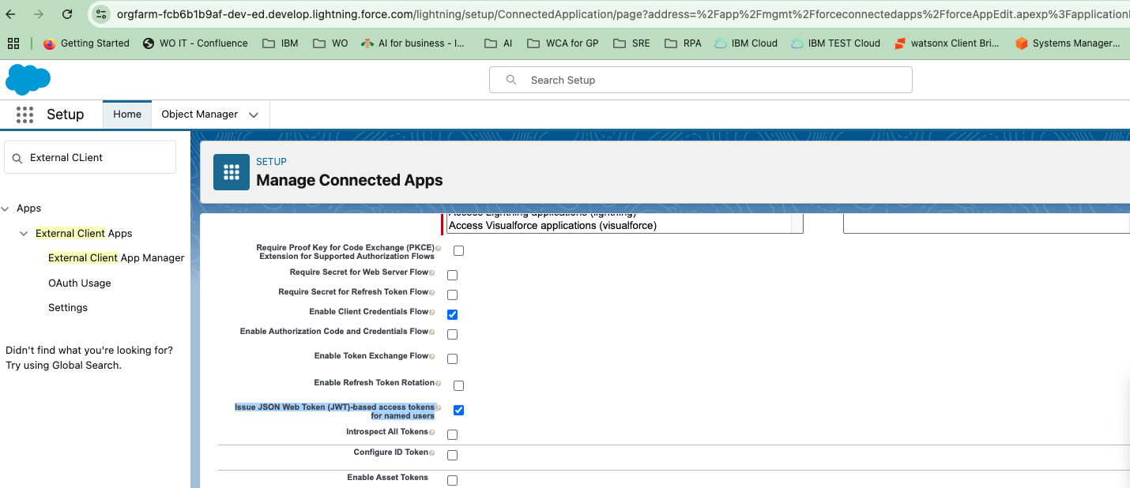

* 1. Then Save

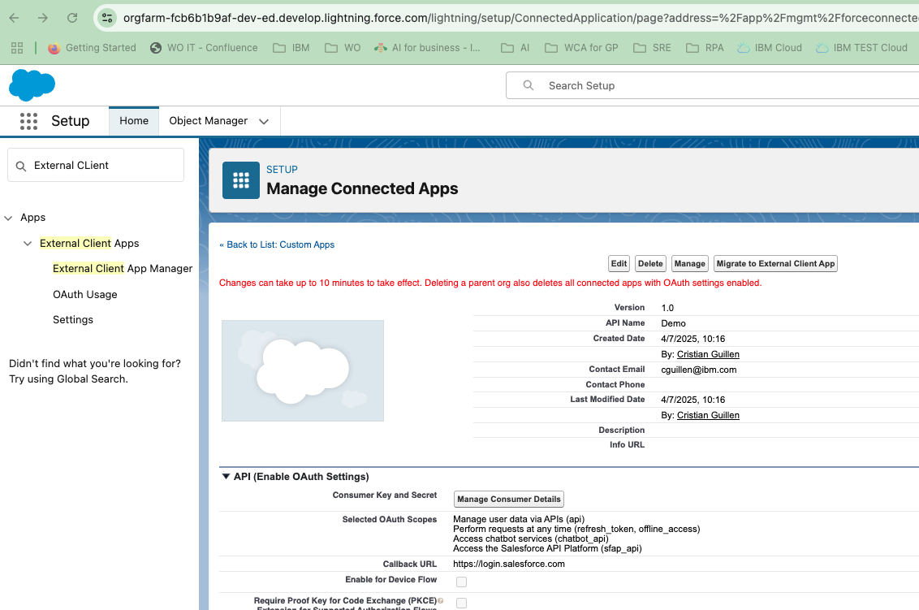

* 1. Then click Manage, then Edit policies
  2. Setup the user in **Client Credentials Flow**

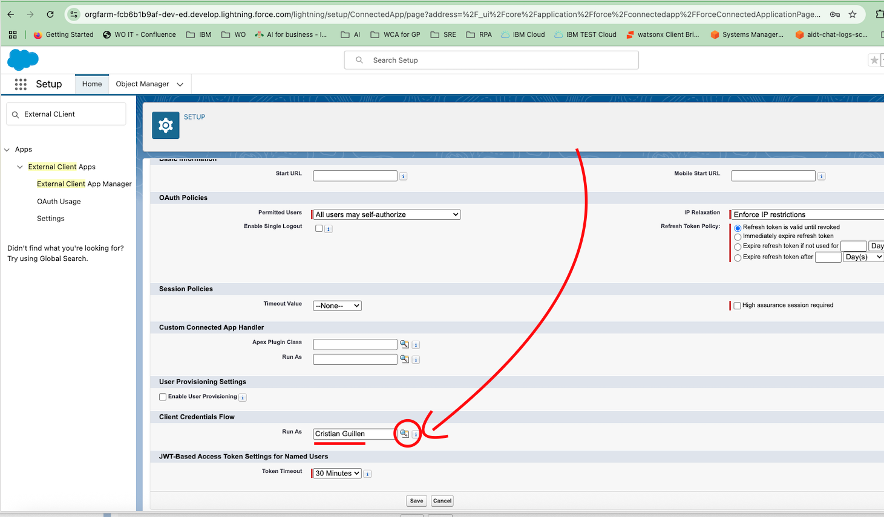

* 1. Then come back to app manager
  2. Look for Demo app and click **view**

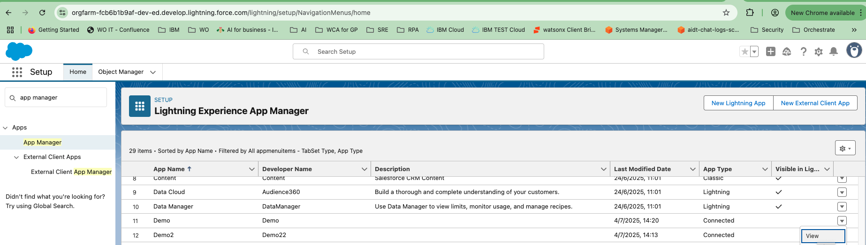

* 1. Click manage Consumer Details

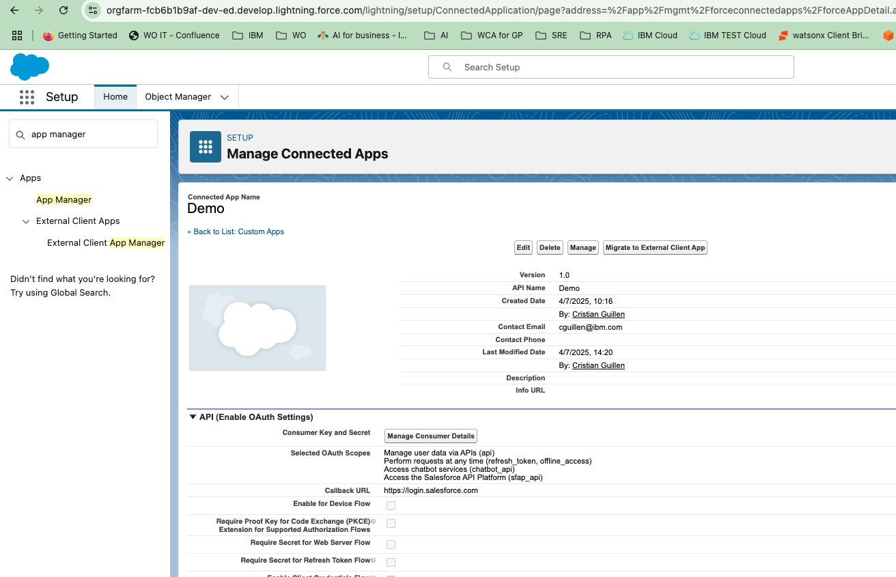

* 1. Copy the two keys provided and saved in a secure location

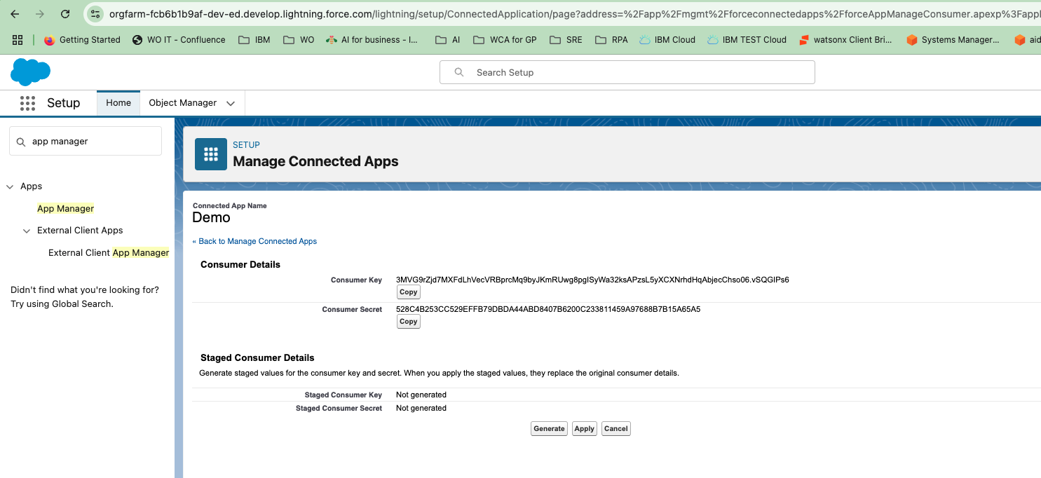

**Consumer Key**

**3MVG9rZjd7MXFdLhVecVRBprcMq9byJKmRUwg8pgISyWa32ksAPzsL5yXCXNrhdHqAbjecChso06.vSQGIPs6**

**Consumer Secret**

**528C4B253CC529EFFB79DBDA44ABD8407B6200C233811459A97688B7B15A65A5**

## **Look for the domains**

Look for “my domain” save the “**Current My Domain URL**” in the same pace than the keys above

|  |  |
| --- | --- |
| **Current My Domain URL** | **orgfarm-fcb6b1b9af-dev-ed.develop.my.salesforce.com** |

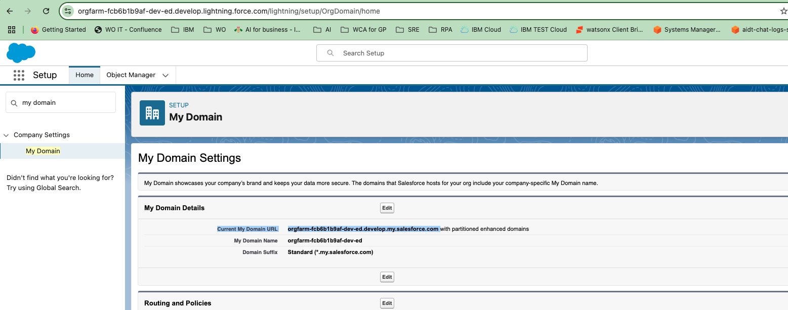

## **Connections**

Then create the following keys in the draft/live setting of watson orchestrate:

* base_url, use the domain above with the https:// prefix
* token_url, use the domain above with this path /services/oauth2/token
* client_id, use the consumer key
* secret, use the consumer secret
* Domain, use the domain above **without** salesforce.com suffix

### Example

"base_url": "<https://orgfarm-fcb6b1b9af-dev-ed.develop.my.salesforce.com>",

"token_url": "<https://orgfarm-fcb6b1b9af-dev-ed.develop.my.salesforce.com/services/oauth2/token>",

"client_id": "3MVG9rZjd7MXFdLhVecVRBprcMq9byJKmRUwg8pgISyWa32ksAPzsL5yXCXNrhdHqAbjecChso06.vSQGIPs6",

"client_secret": "528C4B253CC529EFFB79DBDA44ABD8407B6200C233811459A97688B7B15A65A5",

"domain": "orgfarm-fcb6b1b9af-dev-ed.develop.my"

## **Testing**

## Prompt

create a lead for IBM with contact Cris1 and email [cguillen1@ibm.com](mailto:cguillen1@ibm.com) and phone number 50683400653 state California city San Jose country USA

## Expected

